# DISTRIBUTED SYSTEMS LAB

## PRODUCTION OPERATIONS

### Clusters

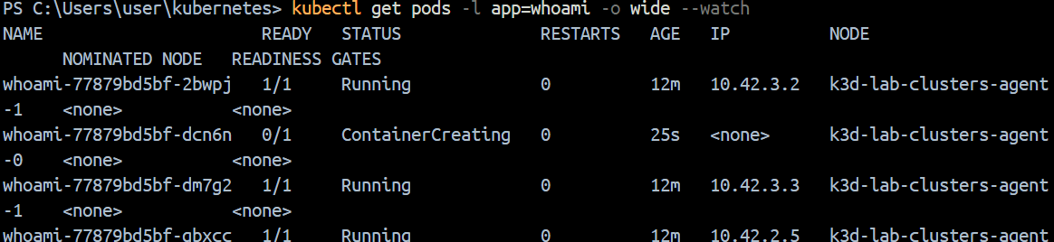

### Affinity

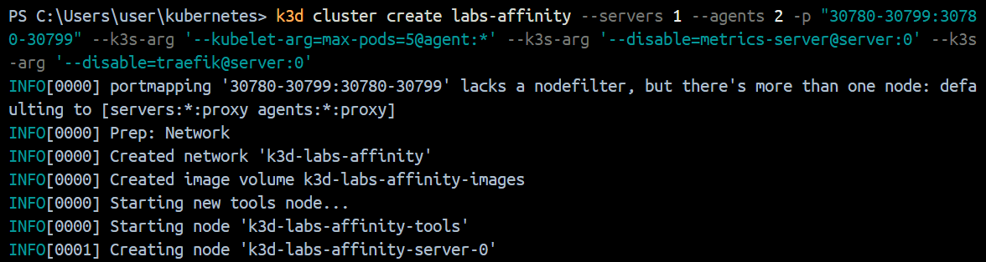

### Tools





